

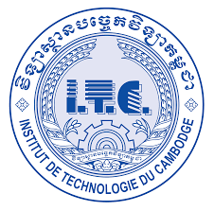



**INSTITUTE OF TECHNOLOGY OF CAMBDIA**

DEPARTEMENT OF INFORMATION AND COMMUNICATION ENGINERING

Subject : Internet Programming

Lecturer : HOK TIN

TD02

Student Name

Tuon Sreynit ID : e20191215

2022-2023